Evaluating the Relationship Outcomes using Survey of Couples
Student’s Name
Course Name & Number
Instructor’s Name
Date Submitted

Evaluating the Relationship Outcomes using Survey of Couples
Introduction
Marriage is a significant social norm in the South East Asian communities it is believed to have a dominant role in family structuring. However in the contemporary society with changing paradigms, the traditional ideal family model based on married couple is gradually being replaced by new family forms. The emerging forms such as the single parents’ culture, people opting to voluntary stay single, live-in partners who cohabit together without formal marriage, remarried couples are gaining much popularity. These changes can be attributed to the new lifestyle trends and greater emphasis to individualization which has actually made the need for marriage and family redundant. The recent studies probe this transformational process with the perspective to understand the linkage between the different family forms and the implications it has on the relational outcomes such happiness, well-being and satisfaction. The study by Kim & McKenry (2002) has yielded an evaluation of the linkage between marital status as well as the psychological well-being of the couples based on the National Survey of Families and Households’ panel data. In this study the marital status information was distributed across eight classes and then its linkage with psychological well-being as probed. The study findings indicated the presence of a significant impact. Another study by Evans & Kelly (2004) has evaluated the impact of family arrangements on the perceived well-being indicated by life satisfaction. Their findings reveal that the formally married couples exhibited greater extent of satisfaction as compared to the couple devoid of such arrangement. This study attempts to examine the link between the marital status with the relationship outcomes such as perceived relationship quality and perceived happiness level among the couples on the basis of the ratings. The study findings exhibit a significant disparity in the average ratings assigned by the couples to the relationship outcomes such as perceived happiness level and perceived relationship quality that characterizes their relationship across the couples who are formally married and the ones who are cohabiting without any formal marriage; implying that the marital status of the couple influences their relationship outcomes.
Study Hypotheses
The study aims to investigate the role of marital status in explaining the relationship outcomes such as the perceived relationship quality and perceived level of happiness hence the following hypotheses are postulated:
Null Hypothesis (H₀₁₎: The perceived level of happiness does not significantly depend on the marital status of the couples thus the ones who are formally married and the others who are cohabiting in other family forms exhibit similar happiness level on an average.
Alternative Hypothesis (H₁₁₎: The perceived level of happiness significantly depends on the marital status of the couples thus there is a significant difference in the perceived level of happiness between the two kinds of couples.
With respect to perceived relationship quality the hypothesis is as follows:
Null Hypothesis (H₀₂₎: The perceived quality of relationship does not significantly depend on the marital status of the couples.
Alternative Hypothesis (H₁₁₎: The perceived quality of relationship significantly depends on the marital status of the couples.
Further an assessment of the relationship between the perceived happiness level and perceived relationship quality is also examined using the graphical tool called scatter plot (Kaplan & Saccuzzo, 2017).
Data Collection
The study uses an internet based survey on forty couples as subjects. The study subjects are the couples hailing from Southeast Asian countries. A deliberate attempt was made to select the participants from diverse demographic backgrounds with varied education groups, varied occupations, diverse income brackets and social classes. It was also ensured that the same sex couples are not included in this sample otherwise no other discrimination is made. The participants chosen from different backgrounds ensure reduction in systematic sampling bias and greater generalizability of study findings (Revelle, 2017). The survey form was a structured instrument with questions in all. The questions pertaining to income of the partners, their age, and happiness ratings were quantitative in nature. The questions for the occupation of the partners, their gender and education, region of the residence as well as the marital status of the couple were qualitative in nature. However for the sake of analysis the information on the qualitative questions was also quantified.
Summary Statistics
Age Female Partner (years) |  | Age Male Partner (years)
Mean | 33.75 | Mean | 35.175
Standard Error | 1.557756 | Standard Error | 1.552454
Median | 31.5 | Median | 34.5
Mode | 27 | Mode | 25
Standard Deviation | 9.852112 | Standard Deviation | 9.818579
Sample Variance | 97.0641 | Sample Variance | 96.40449
Kurtosis | -0.50042 | Kurtosis | -0.46217
Skewness | 0.683417 | Skewness | 0.623296
Range | 37 | Range | 38
Minimum | 21 | Minimum | 20
Maximum | 58 | Maximum | 58
Sum | 1350 | Sum | 1407
Count | 40 | Count | 40
As seen from the above summary statistics the average age of the female partners (34 years) is lesser than their male counterparts (35 years). However the modal age seems a bit higher. The variation in the age distribution for both the partners is almost similar around 9.8 years. Both the age distribution depicts positive skewness.
Income Male Partner ($) |  | Income Female Partner ($)
Mean | 48700 | Mean | 42662.5
Standard Error | 5252.862 | Standard Error | 5299.473
Median | 42500 | Median | 37500
Mode | 35000 | Mode | 0
Standard Deviation | 33222.02 | Standard Deviation | 33516.81
Sample Variance | 1.1E+09 | Sample Variance | 1.12E+09
Kurtosis | 4.204389 | Kurtosis | 0.633951
Skewness | 1.618636 | Skewness | 0.9269
Range | 175000 | Range | 140000
Minimum | 0 | Minimum | 0
Maximum | 175000 | Maximum | 140000
Sum | 1948000 | Sum | 1706500
Count | 40 | Count | 40
As seen from the above data the average income of the male counterparts (48700 dollars) is higher than that of the average income of females (42663 dollars). One interesting fact which arises from the above table is that the modal income of the female cohort is zero implying that a large pool of women remains non-earning. Again both the income curves also indicate positive skewness.
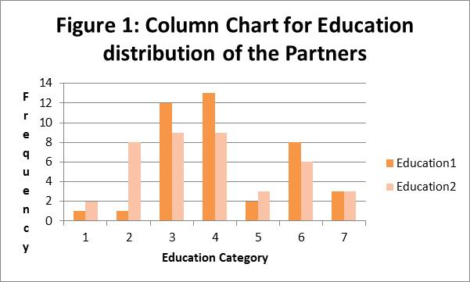
The above graph represents the education distribution of the partners where the education1 variable represents the education level of the male partner and the variable education2 depicts the education level of the female partner. The length of each column depicts the frequency of occurrence of that specific education category; as seen in this graph the males in the higher education category outnumber the count of women. Thus it can be concluded that the male partner is usually more educated than his female counterpart.
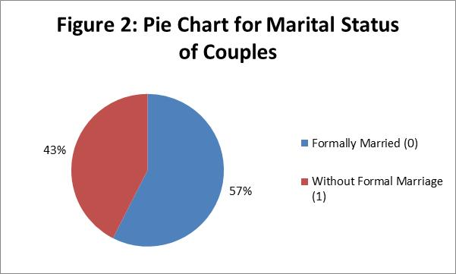
The above pie chart exhibits the break-up of the entire sample of 40 couples on the basis of their marital status. As seen in this pie-graph the percentage of couples who are formally married is 57% whereas the remaining 43% are living together without any formal arrangement.
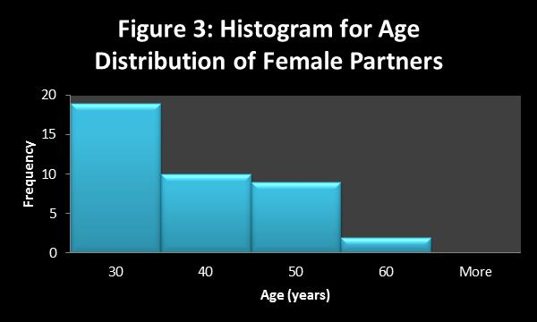
The above histogram shows the frequency distribution of ages of the female partners.
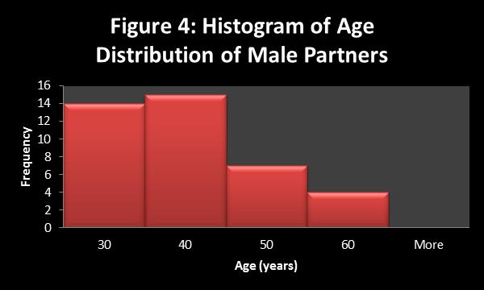
The above histogram shows the frequency distribution of ages of the male partners.
Figure 5: Scatter Plot of Perceived Happiness Level
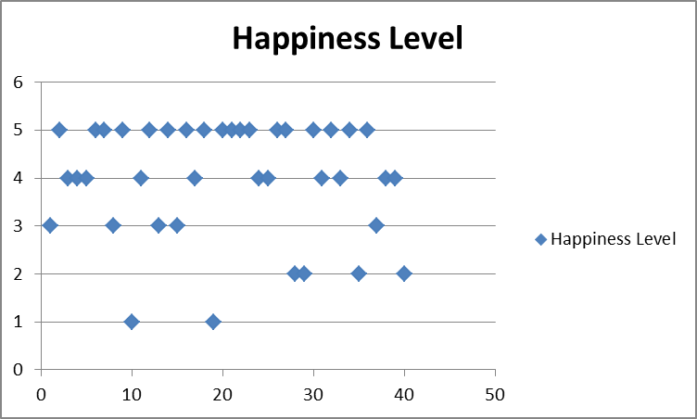
As evident in the scatter plot there is no clear relationship between the perceived relationship quality and perceived happiness level.
Conclusion
The classification of the data on the basis of the marital status revealed that 17 couples were cohabiting without any formal marriage set-up and on the other hand the other 23 couples were married in a formal manner. The results using independent sample t-test indicates that the average score on perceived level of happiness in the relationship was insignificantly different for the two groups of couples (insignificant value of t-statistic for 38 degrees of freedom at 5% level of significance) indicating the two groups of the couples experience similar extent of happiness regardless of their marital status.
t-Test: Two-Sample Assuming Equal Variances
 | Happiness Level0 | Happiness Level1
Mean | 4 | 3.956522
Variance | 1.25 | 1.679842
Observations | 17 | 23
Pooled Variance | 1.498856
Hypothesized Mean Difference | 0
Df | 38
t Stat | 0.111033
P(T<=t) one-tail | 0.456087
t Critical one-tail | 1.685954
P(T<=t) two-tail | 0.912175
t Critical two-tail | 2.024394

On the other hand, the results for the average score on perceived relationship quality reveal that there is a significant between the two couple groups (significant t-value for 38 degrees of freedom).
t-Test: Two-Sample Assuming Equal Variances
 | Perception of Relationship Quality0 | Perception of Relationship Quality1
Mean | 2.705882 | 4
Variance | 0.220588 | 0
Observations | 17 | 23
Pooled Variance | 0.092879
Hypothesized Mean Difference | 0
Df | 38
t Stat | -13.2762
P(T<=t) one-tail | 3.77E-16
t Critical one-tail | 1.685954
P(T<=t) two-tail | 7.54E-16
t Critical two-tail | 2.024394

Further examination of the mean values of the relationship quality perception indicate that for the perceived relationship quality the perception is much higher in the married group with mean perception rating of 4 as compared to the other couple group without marriage whose mean perception rating of relationship quality is as low as 2.57.
Sources of Potential Bias
The use of a quantitative research design based on the structured instrument with pre-validated measurement scales ensures that the measurements do not have any subjectivity error. In addition to this the quantitative analytical tools also yield objectivity to the study.
The possible limitations in the study arise due to small sample size, the internet survey where the respondents’ are anonymous and it is difficult for the researcher to exercise control over the background environment. Lack of control on respondents’ identity can induce distortion in the study findings. Also the use of cross-sectional research design data might not be indicative of the causal relationship between the marital status and relationship outcomes.

References
Evans, M. D. R., & Kelley, J. (2004). Effect of family structure on life satisfaction: Australian evidence. Social Indicators Research, 69(3), 303-349.
Kaplan, R. M., & Saccuzzo, D. P. (2017). Psychological testing: Principles, applications, and issues. Nelson Education.
Kim, H. K., & McKenry, P. C. (2002). The Relationship Between Marriage and Psychological Well-being A Longitudinal Analysis. Journal of Family Issues,23(8), 885-911
Revelle, W. R. (2017). psych: Procedures for personality and psychological research.

